

Yenepoya Institute of Arts, Science, Commerce, and Management
Project – High Level Design
on

Big Data Analytics for Retail Demand

Student Name: HARINAND.A

Industry Mentor:
Mr Shashank korram

Guided by: Ms. Suzana Sharol

YIASCM | PROJECT 2026
1



Table of Contents

No. | Section Title | Page
1 | Introduction
1.1 | Scope of the Document
1.2 | Intended Audience
1.3 | System Overview
2 | System Design
2.1 | Application Design
2.2 | Process Flow
2.3 | Information Flow
2.4 | Components Design
2.5 | Key Design Considerations
2.6 | API Catalogue
3 | Data Design
3.1 | Data Model
3.2 | Data Access Mechanism
3..3 | Data Retention Policies
3.4 | Data Migration
4 | Interfaces
5 | State and Session Management
6 | Caching
7 | Non-Functional Requirements
7.1 | Security Aspects
7.2 | Performance Aspects
8 | References

YIASCM | PROJECT 2026
2



- Introduction
The rapid growth of digital retail systems has led to the generation of large volumes of transactional data. Analyzing this data is essential for understanding customer behavior, identifying demand patterns, and improving business decision-making.

This project, Big Data Analytics for Retail Demand, focuses on analyzing retail transaction data using Python, Pandas, and SQLite. Instead of working with large-scale distributed systems, the project simulates core Big Data concepts such as ETL (Extract, Transform, Load) using a manageable dataset.

The system processes historical retail data to extract meaningful insights related to product categories, customer segments, geographical
distribution, and time-based trends. These insights are visualized to support data-driven decision-making.

  - Scope of the Document
This document presents the High-Level Design (HLD) of the Retail Demand Analysis system. It defines the system architecture, data processing workflow, and major components involved in analyzing retail data..
In Scope:
    - Data extraction from CSV dataset
    - Data cleaning and preprocessing
    - Feature engineering ( Month, Day ofWeek, Revenue in Millions)
    - SQL-based aggregation (GROUP BY, SUM)
    - Data storage using SQLite
    - Data visualization and reporting

YIASCM | PROJECT 2026
3



Out of Scope:
- Real-time streaming data processing
- Distributed systems such as Hadoop or Spark
- Machine learning or predictive modeling
- External API integrations

  - Intended Audience
This document is intended for:
    - Project Evaluators / Mentors – to assess system design and implementation quality
    - Developers / Students – to understand system workflow and architecture
    - Data Analysts (Beginners) – to learn data processing and analysis techniques

  - System Overview

The Retail Demand Analysis system is designed as a structured data processing pipeline that transforms raw retail transaction data into meaningful insights.
The system begins by loading a CSV dataset containing retail transactions. The data is then passed through a preprocessing
stage where missing values are handled, data types are corrected, and new features such as Month Name, and Day of Week are created.
After preprocessing, the processed data is stored in a SQLite database. SQL queries are then used to perform aggregation
operations such as GROUP BY and SUM to generate summarized results.

YIASCM | PROJECT 2026
4



The aggregated data is retrieved and visualized using charts such as bar graphs, line charts, and donut charts to represent trends and patterns.
This pipeline-based design ensures clarity, modularity, and ease of understanding, making it suitable for learning and demonstrating Big Data concepts on a manageable dataset.

- System Design

  - Application Design
The system follows a modular and pipeline-based architecture, where each stage is responsible for a specific function in the data processing lifecycle.
The workflow begins with the data ingestion module, which loads the CSV dataset into the system. The data is then passed to the preprocessing stage, where data cleaning, transformation, and feature engineering are performed. This includes handling missing values, correcting data types, and creating new features such as Month, day of week, , and Revenue in Millions.
After preprocessing, the processed data is stored in a SQLite database, which acts as a lightweight storage layer.
SQL queries are then executed on the stored data to perform aggregation
operations such as GROUP BY and SUM. These queries generate summarized results for analysis.
Finally, the visualization module generates graphical outputs such as bar charts, line graphs, and pie charts to represent trends and patterns. These visualizations help in deriving meaningful insights and supporting decision- making.
This modular pipeline design ensures clarity, separation of concerns, and ease of understanding, making the system suitable for analytical and educational purposes.

YIASCM | PROJECT 2026
5



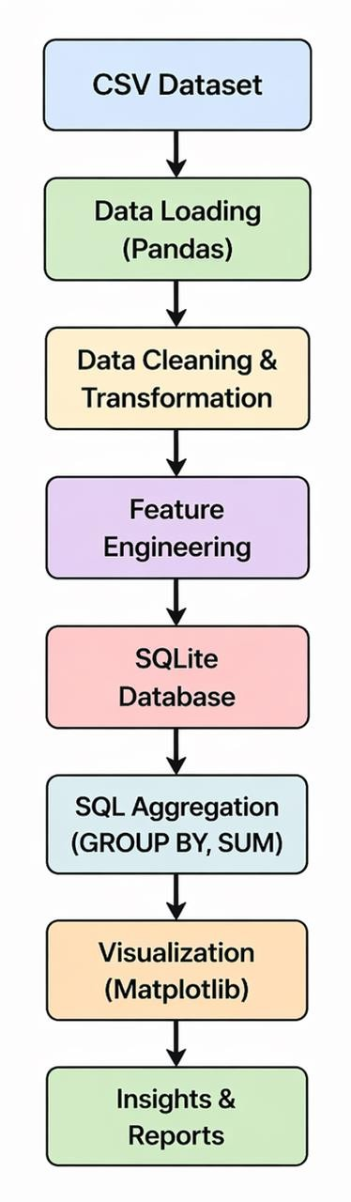

Process Flow
The system follows a sequential data processing pipeline:

- Load dataset from CSV file
- Perform data cleaning (remove null values, fix formats)
- Extract features (Year, Month)
- Filter dataset for consistency (2023 data)
- Perform aggregation using GroupBy
- Store processed data in SQLite database
- Generate visualizations and insights

This process ensures that raw data is systematically transformed into meaningful analytical outputs.

YIASCM | PROJECT 2026
6



Information Flow
Input:
    - CSV retail dataset Processing:
    - Data cleaning and preprocessing
    - Feature engineering (Month, day of week, Revenue in Millions)
    - Data stored in SQLite database
    - SQL aggregation using GROUP BY and SUM

Output:
    - Aggregated data (category-wise, monthly trends)
    - Visualizations and insights

Components Design
The system is divided into the following modules:

- Data Loading Module
Loads dataset from CSV using Pandas
- Data Cleaning Module
Handles missing values and formats data

YIASCM | PROJECT 2026
7



- Feature Engineering Module
Creates new features such as Month, day of week, Revenue in Millions
- Database Module
Stores processed data in SQLite
- SQL Aggregation Module
Performs data aggregation using GROUP BY and SUM
- Visualization Module
Generates charts for analysis and insights

Key Design Considerations
- Simplicity: Easy to understand and implement
- Performance: Efficient processing using Pandas
- Scalability: Can be extended to larger datasets
- Accuracy: Ensures correct data transformation

API Catalogue

No external APIs are used in this system.
Data retrieval and analysis are performed using SQL queries on the SQLite database.

YIASCM | PROJECT 2026
8



Data Design

Data Model
The system uses a structured dataset representing retail transactions. The data model is designed to capture customer behavior, product details, and transaction information.
Each record represents a single transaction and contains the following attributes:
    - Customer ID: Unique customer identification
    - Product Category: Category of product
    - Quantity: Units purchased
    - Price: Price per units
    - Date: Transaction date
    - Month: Extracted month
    - PaymentMethod: Payment type
    - Day of Week: Day name
    - Revenue: Total Revenue

This structured format enables efficient aggregation and analysis.

Data Access Mechanism
The system uses a hybrid approach for data access:

- Pandas: Used for loading, processing, and transformation
- SQLite: Used for storing processed data
- SQL Queries: Used for retrieving aggregated insights This approach ensures flexibility and efficient data handling.

YIASCM | PROJECT 2026
9



Data Retention Policies
    - Data is stored locally in SQLite
    - No automatic deletion mechanism
    - Data is retained for analysis purposes

Data Migration
Data migration is not applicable as the system uses a single local dataset.

Interfaces
- CSV file as input data source
- Pandas for data processing
- SQLite for data storage and retrieval
- Jupyter Notebook for execution and visualization

State and Session Management
The system does not require complex session management as it operates in a batch processing mode.
- Data is processed in-memory using Pandas DataFrame
- Intermediate results are handled during execution
- Final data is stored in SQLite database
- No session persistence beyond execution

YIASCM | PROJECT 2026
10



Caching
Caching is not implemented in this system due to the manageable size of the dataset.
However, for large-scale systems:

- Caching is not implemented due to small dataset size

- Data processing is efficient and does not require caching

Non-Functional Requirements

Security Aspects
The system ensures basic security measures:
    - System runs locally without external data exposure
    - No external APIs or data sharing
    - Data stored securely in local SQLite database

Performance Aspects
The system is optimized for efficient data processing:
    - Uses Pandas for efficient data processing
    - SQL aggregation improves query performance
    - Handles moderate dataset efficiently
    - Performs batch processing (no real-time processing) The system provides near real-time results for analysis.

YIASCM | PROJECT 2026
11



References

The following sources were used for understanding and implementing the project:

- Pandas Documentation – https://pandas.pydata.org/docs/
- Python Documentation – https://docs.python.org/3/

Retail Analysis Dataset (Kaggle) –
https://www.kaggle.com/datasets/fahadrehman07/retail-transaction-dataset

YIASCM | PROJECT 2026
12

